CS590BD Big Data Analytics

Lab 1

Submitted by SAIKIRAN PASALA

Student id: 16154892

E-mail: [spwv8@mail.umkc.edu](mailto:spwv8@mail.umkc.edu)

Task: 2

1. To access UMKC Cloudera servers one should be within umkc or else can connect through VPN. <http://134.193.136.127:7180> is the address for the servers.

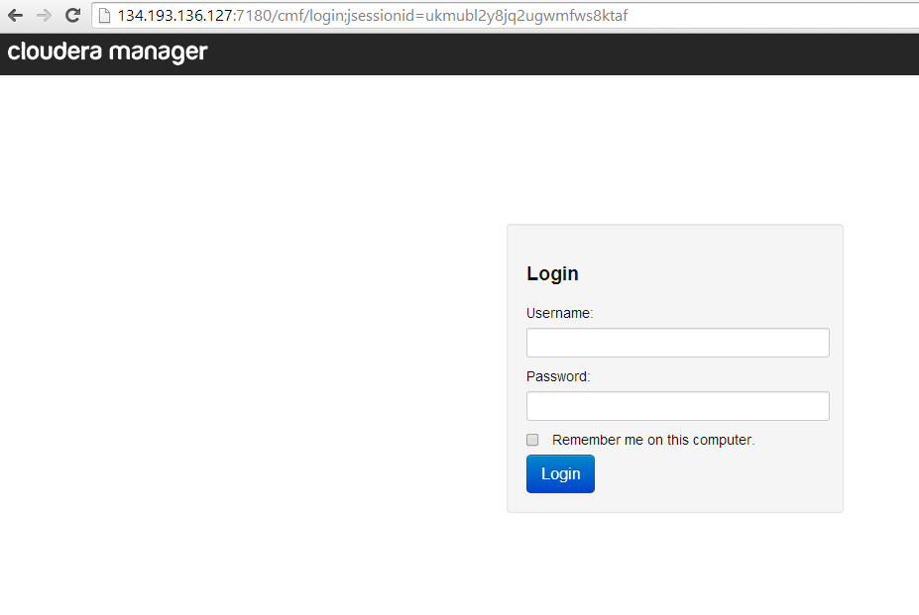

1. To install the cloudera server we first download the vmware player and then the hadoop image (ISO file) is added to the vmware player. Thus we can create a cloudera server in our local machine.

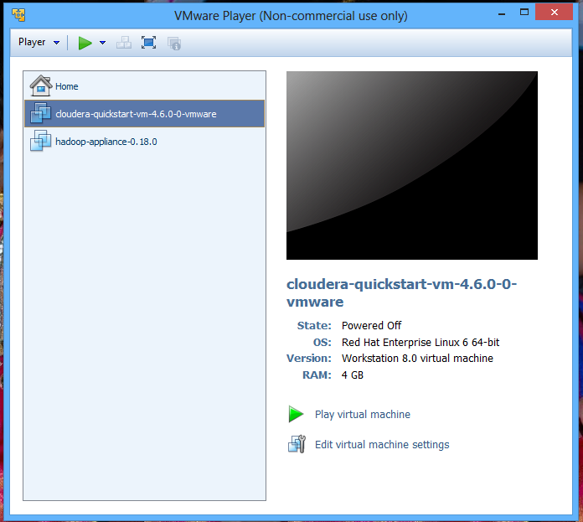

1. To transfer files to cloudera we use WINSCP. Winscp is used to transfer files to the remote servers. We just connect to the server and can just drag and drop the files.

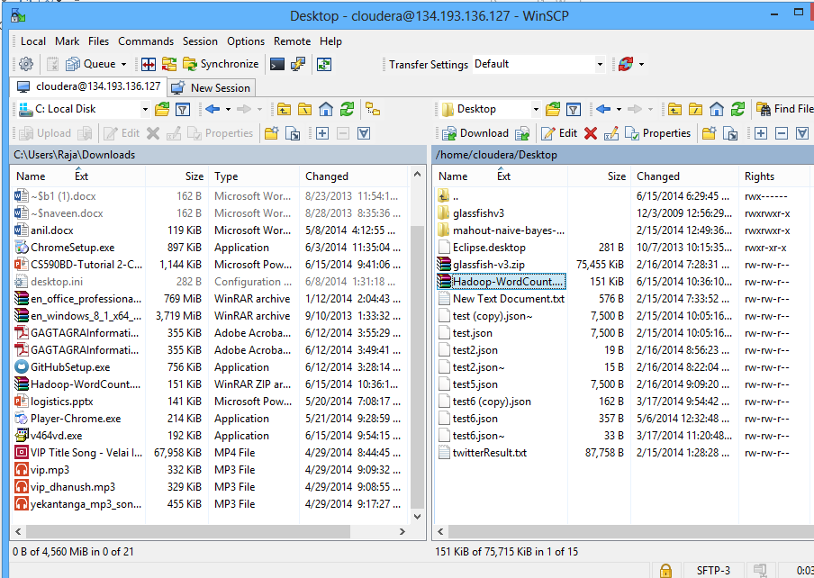

1. Word count example: we first download the rar file and then transfer it to the cloudera and run the wordcount example.

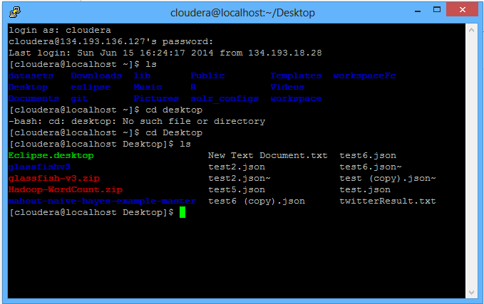

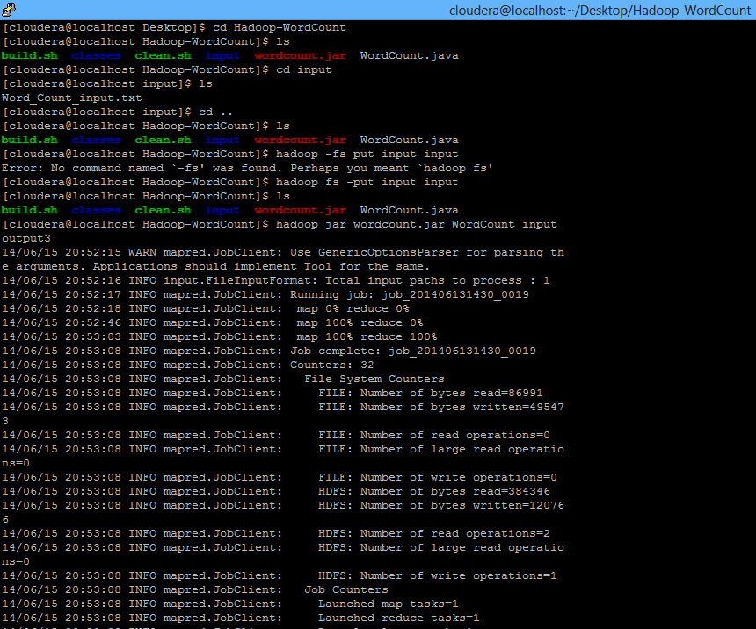

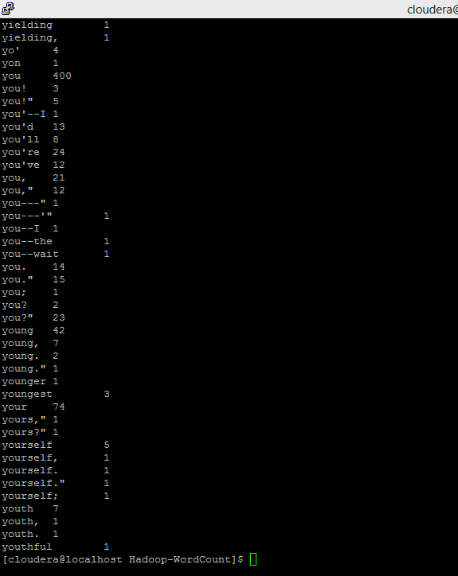

1. Creating hadoop jar is by selecting export option and then run that jar in the cloudera.

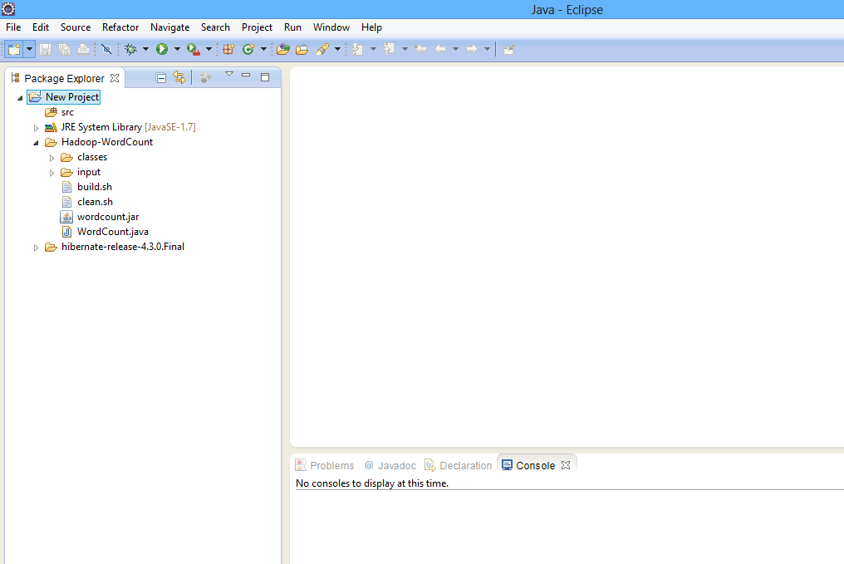

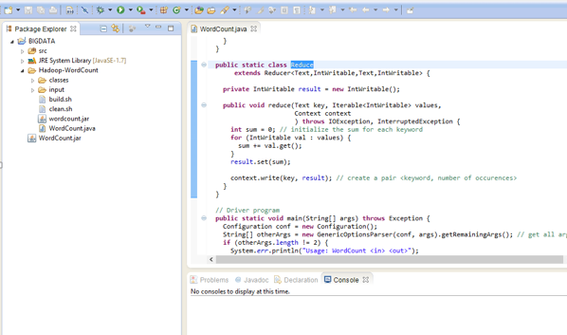

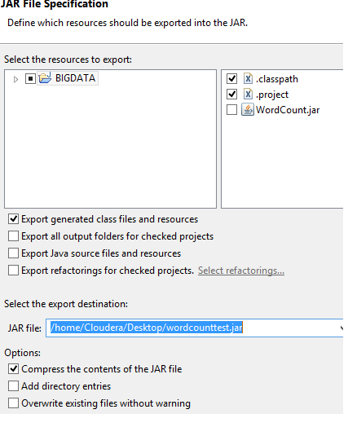

1. First we need to download the OEPE juno and then install the glassfish and then create a rest project.

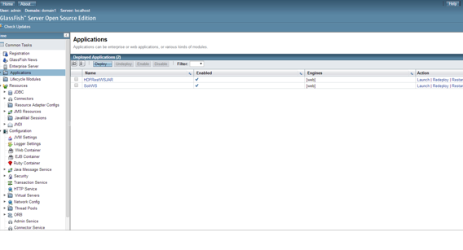

TASK: 3

1. Creating github account and deploying is shown in the below steps.

* Go to github.com and create an account.

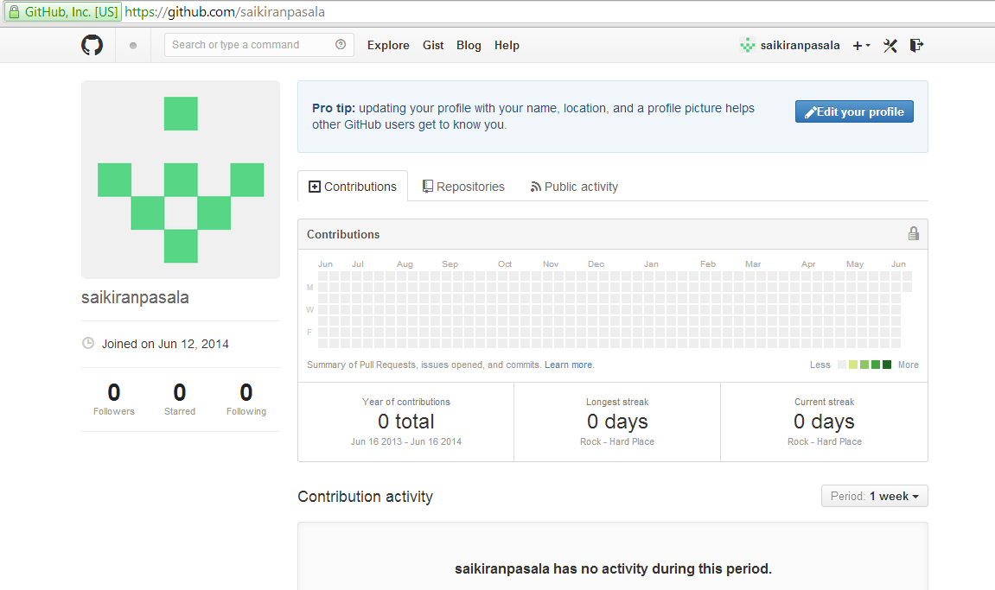

* Install github for windows in your local machine.

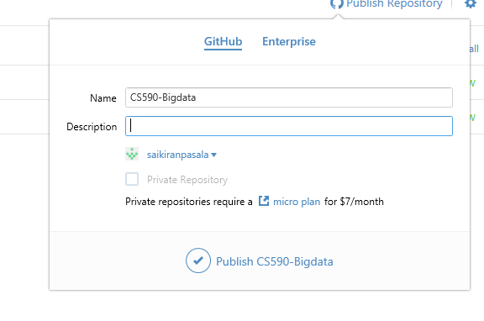

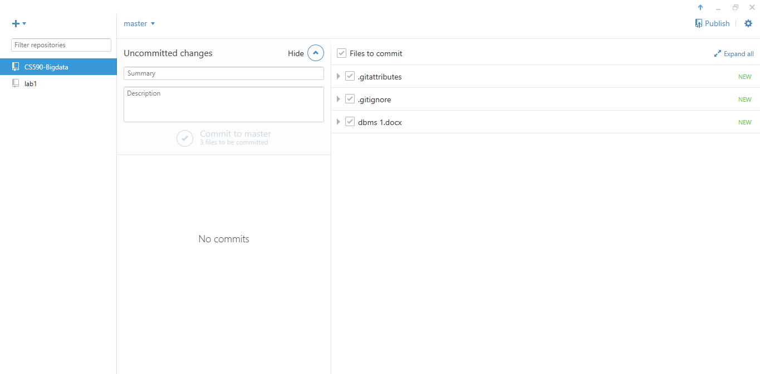

* Create a repository online and make a clone in your local machine and then add files to your repository. If you make changes to your file in local machine the changes can be seen in the repository online.

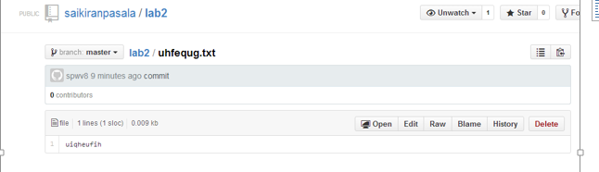

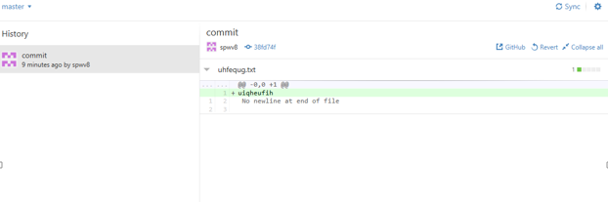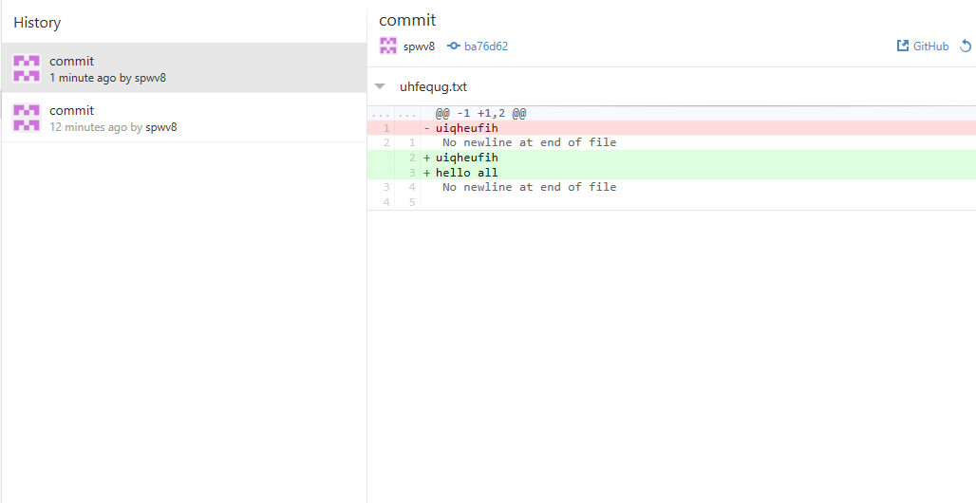

1. Scrumdo: For the scrumdo we first go to the scrumdo.com and create an account with scrumdo. And then check various features that we can use in scrumdo and also deployed a project. These can be seen from the following screenshots.

